SQL Joins

Visual representation --

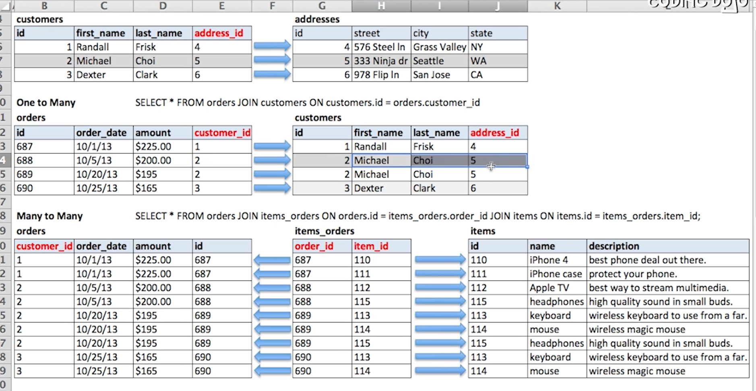

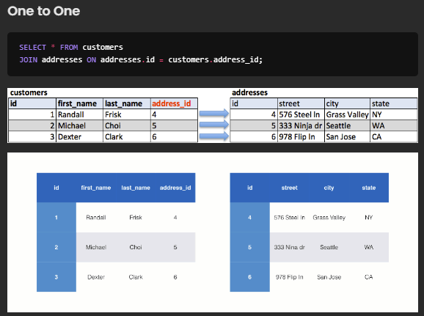

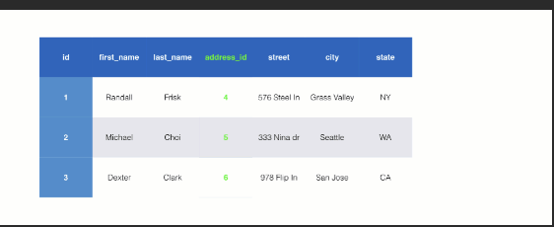

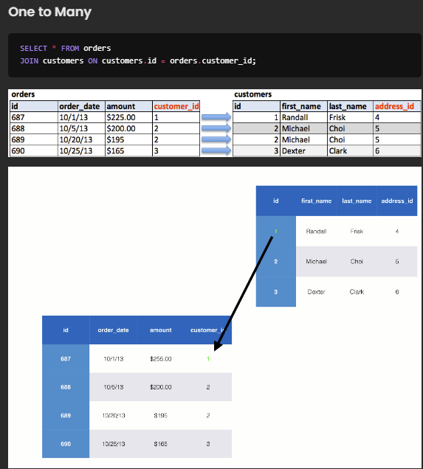

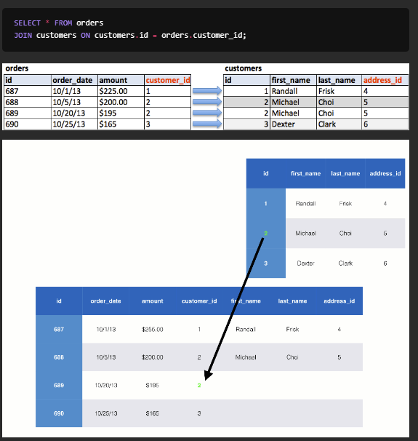

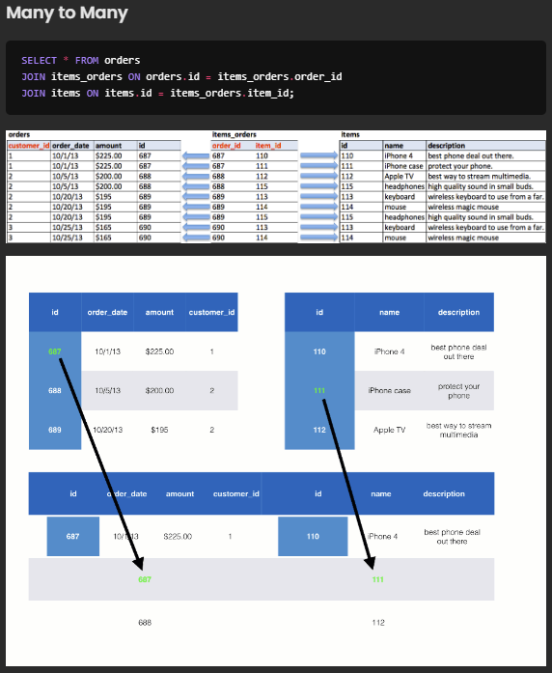

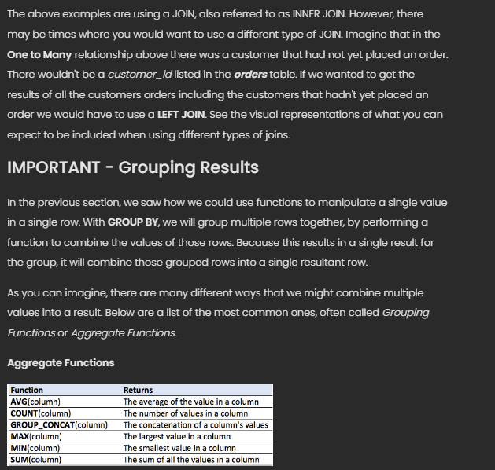

LEFT JOIN

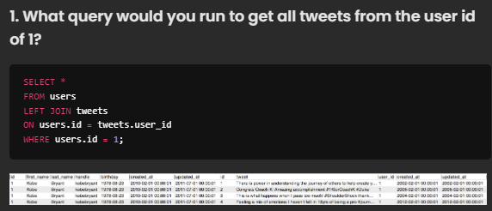





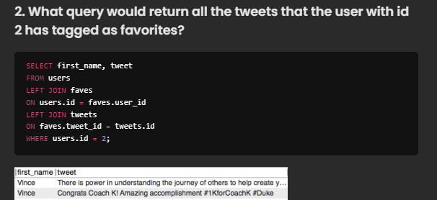



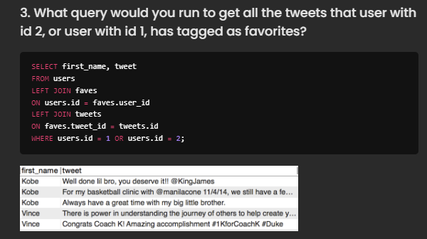



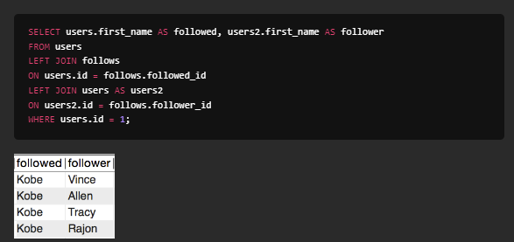



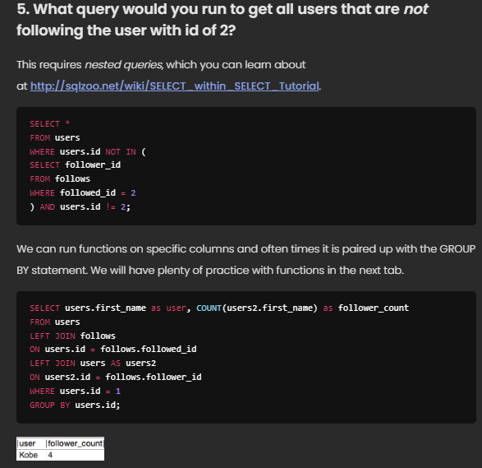

Left Join vs. Join

As mentioned earlier, LEFT JOIN and JOIN are all that you need for web development. They are very similar, but you should not think of them interchangeably. There is a difference in the output that they provide, specifically in the cases where a record in one table has no matching record in the joining table.

For example, running the following SQL command in our ***twitter*** database will result in the following:

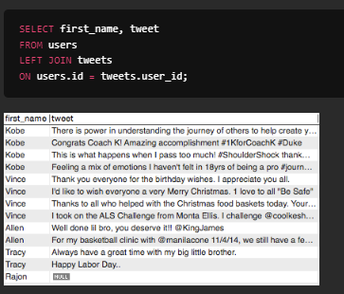

Notice that this result includes a final row containing Rajon with no associated tweet.

Now if we change the LEFT JOIN command to the JOIN command, the output will be as follows:

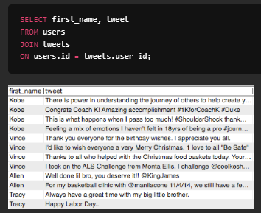

In the second example, Rajon is omitted from the table. When SQL uses the keyword JOIN, it only includes those records that have matches on both sides. It will omit any records that don't have a 'partner'.

On the other hand, LEFT JOIN will include all the records from the first table (the 'left' table, the first one mentioned when reading from left to right), regardless of whether that record has a matching foreign key in the (right) table that we are trying to join to it.

To summarize, JOIN will only include the intersection of the two tables, whereas LEFT JOIN will include all records from the first table, plus the records from the second table that correspond. This is why the JOIN is sometimes called the INNER JOIN, while all the other joins (including LEFT JOIN) are referred to as OUTER JOINs.

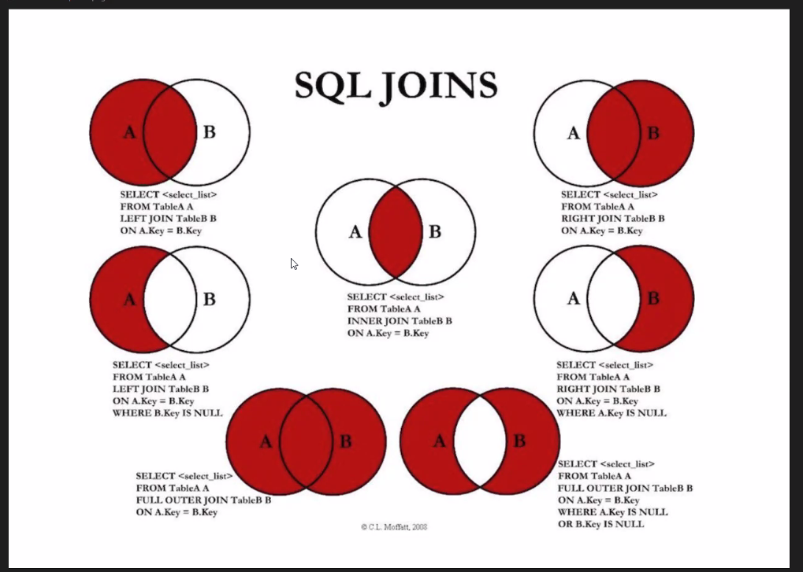

Example joins of just specific fields

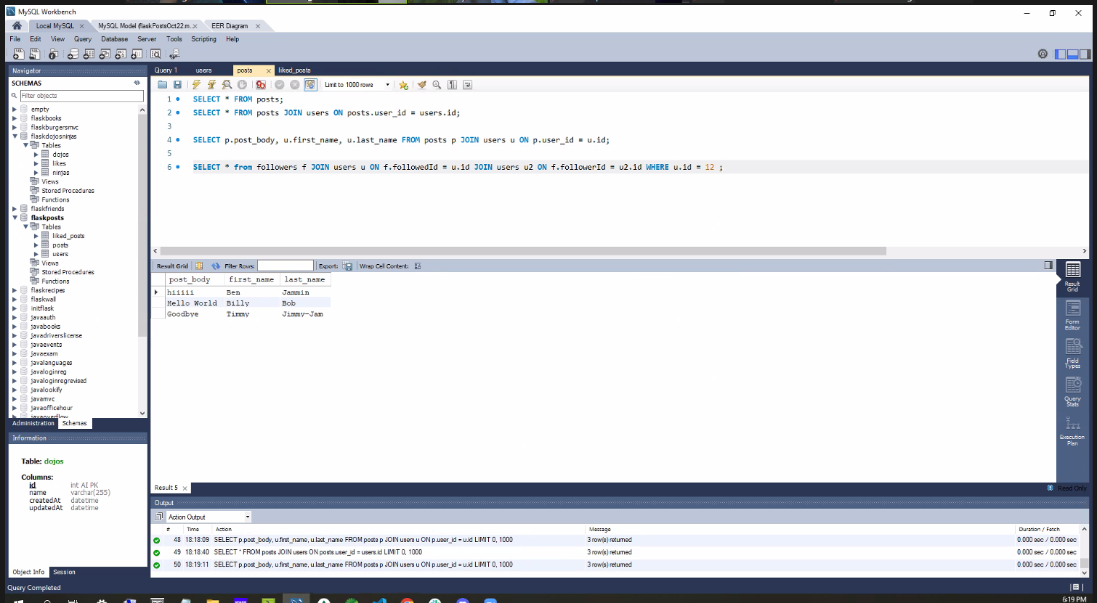

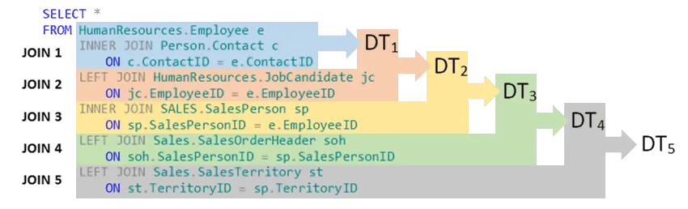

How to limit and offset without knowing last value

SELECT *

FROM(

SELECT

*,

ROW_NUMBER() OVER() row_num

FROM

cities

) tmp

WHERE

row_num > 8;